**Continuous Monitoring on Docker with ELK Stack**

Steps to be followed:

1. Set up ELK stack on Docker
2. Configure Jenkins pipeline for Docker build and deployment
3. Run the Spring Boot application and check the logs in Kibana

**Step 1: Set up ELK stack on Docker**

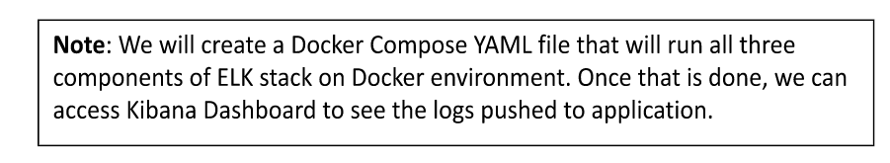

1. Download Docker compose file in one of the git repositories and follow the set of commands given below to initialize the ELK stack.

***sudo su***

***git clone*** <https://github.com/raushan8586/ELKExample.git>

***cd ELKExample***

***ls -alrt***

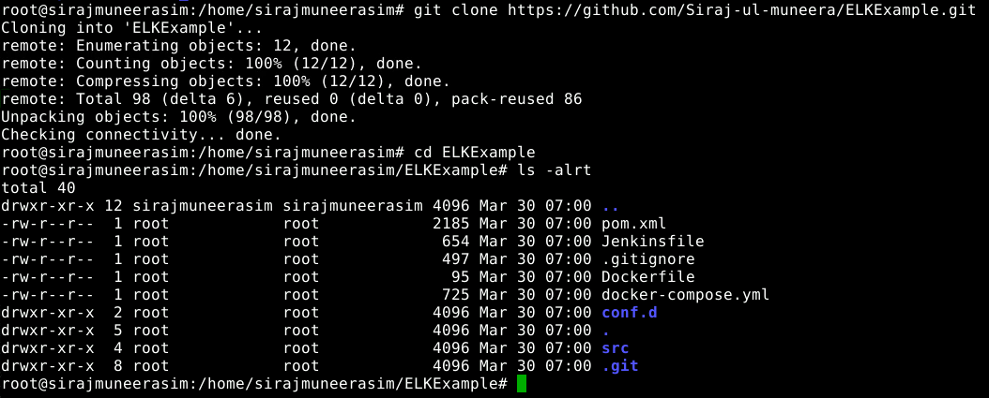

1. Start the ELK stack using the docker-compose command. Usually, this binary is not installed on a server. So, follow the set of commands given below to install Docker Compose.

***apt install docker-compose***

***docker-compose version***

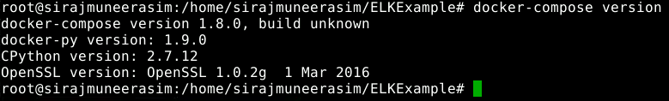

1. Before starting the ELK stack, run the command given below so that elastic search is configured properly.

***sysctl -w vm.max_map_count=262144***

1. Run the docker-compose command to initialize the ELK stack.

***docker-compose up -d***

***docker ps***

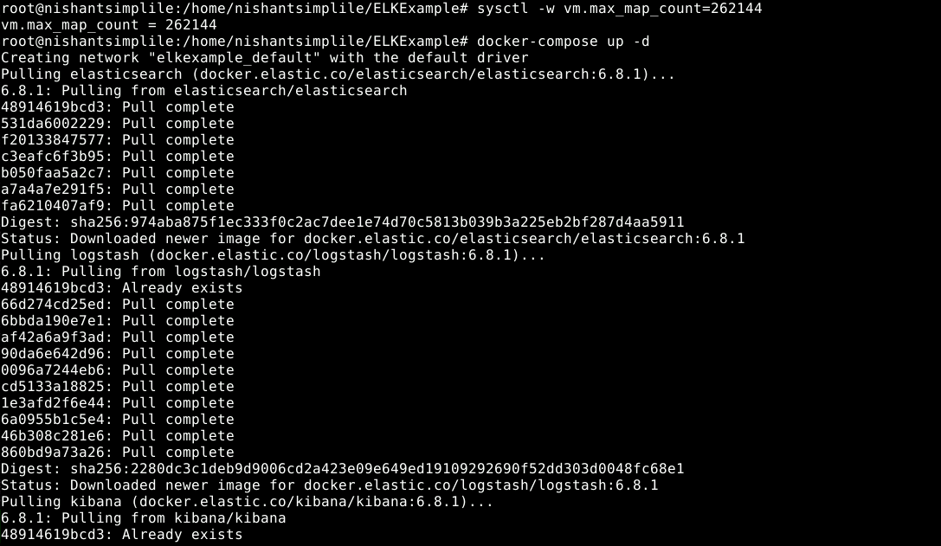

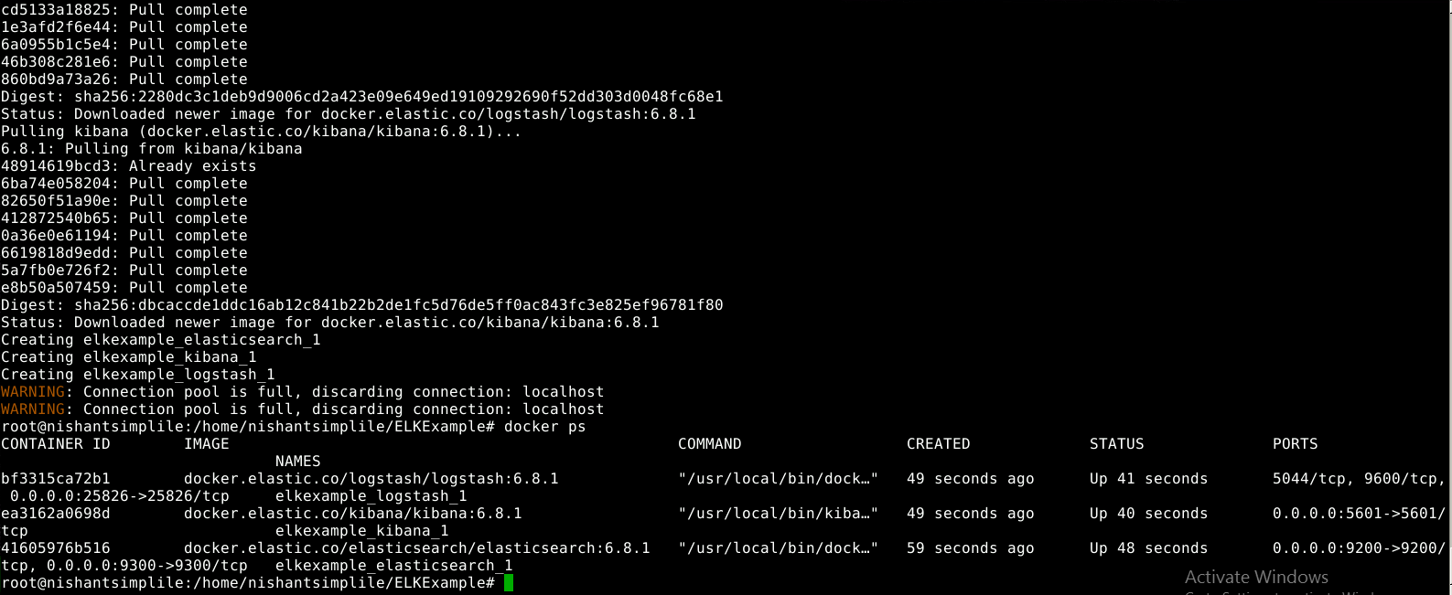

1. Open the Kibana URL using the public IP of the host and 5601 port to access the Kibana dashboard.

***http://localhost:5601/app/kibana***

